IT SERVICES FOR IIITB INFRASTRUCTURE
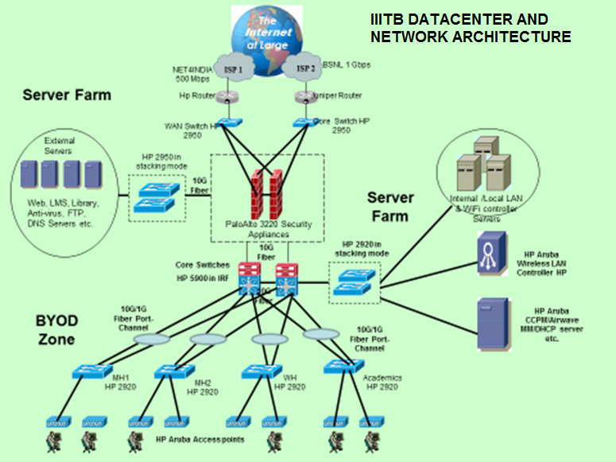
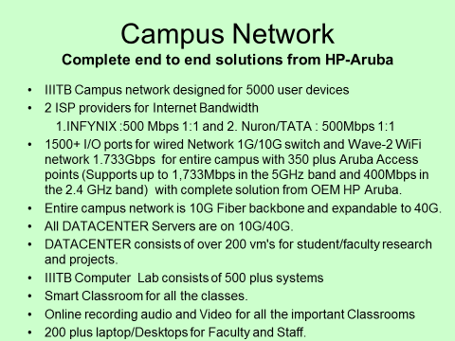
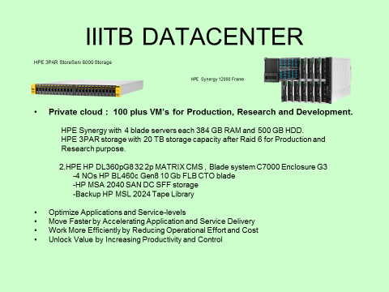
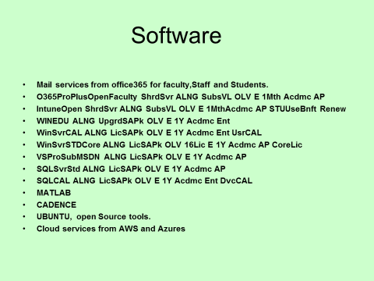
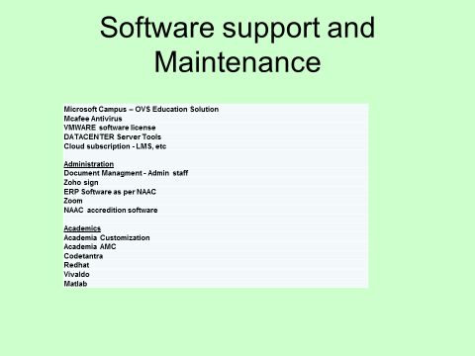

IIIT-B’s Requirement
1. DATACENTER SUPPORT AND CAMPUS NETWORK SUPPORT
2. Help Desk Support Services
3. Vendor Management Services

1: DATACENTER SUPPORT AND CAMPUS NETWORK SUPPORT (1 DATACENTER + 1 L2 NETWORK 3 L1 Desktop Engineer = 5 on-site engineers at IIIT-B)
Requirement: 1 DATACENTER administrator + 4 L1 & 2 NETWORK support on-site engineers at IIIT-B and with backend NOC support for 24/7 for the contract period of 12 months to provide the following services:
- To provide level 1 to Level 3 support & maintain the IIITB Infrastructure with respect to all the servers in the DATACENTER, VMWare servers,
SAN Storages, HPC servers, GPU servers, Backup all servers and critical data of clients, Desktops Laptops, Printers, Networking equipment like Switches, Wireless routers etc. at the site.
2. Basic support for Windows 10, Windows 11, Redhat Linux Desktop OS & Ubuntu OS for users.
3. Trouble shooting & Configuration of Applications like MS Office, Open Office, and Antivirus
4. Trouble shooting of Specific Applications support like Matlabs, Cadence etc… with support from respective OEM vendor .
5. Monitoring Palo Alto NEXT GEN Network Firewall for the campus & IP Filtering
6. To raise indents for the faulty spares for the newly deployed hardware from respective OEM vendor
7. Coordinating with vendors / internal team for hardware replacement (If any)
8. Providing L1, L2 and L3 support for all the labs, Application servers, system servers and network services and devices in IIITB DATACENTER.
9. Providing classroom Room IT support like Laptop/Desktop, projectors, audio systems, CCTV DATA footage for any incident requirements etc.…
10. Providing IT support for all IIITB events like convocation, foundation, IT seminars and workshops.

2. Help Desk Support Services and there responsibility.
• Troubleshooting of Desktops, Laptops, Printers, Switches, Routers & Firewall
• Troubleshooting of HP Blade Servers, Rackservers, Backup etc.
• Troubleshooting of HP Cloud System Matrix
• Installing and uninstalling of OS s’ like Windows, Linux, Redhat & Ubuntu OS in all Labs (Computing Labs, CEEMS, HIDES, research labs etc..)
• Hardware asset & report management
• Support all the IIITB events
3. Vendor Management Services
• Log and co-ordinate calls with vendors to resolve issues.
• Manage hardware/software maintenance contracts.
SUPPORT SERVICE SHOULD AIMS AT:
1. Ensuring support calls are adhered to at the time when support is needed
2. Identifying hardware & software problems and trouble shooting them.
3. All Hardware and Software problems will be intimated to the respective software team, vendors or respective users in IIIT-B.
4. Resolving the issue within the stipulated time with respect to L1 to L7 issues and also coordinating with respect venders for any other support.

IT Support staff Duty Schedule
Date
 | Shift - 1 (L1 staff) | L1/L2/L3 Staff General Shift |  | L3 & L1 Shift - 2 | L1 Staff Shift - 3
Time | 8 am to 5 pm | 9 to 6 pm | 11 to 8 pm | 1 pm to 10 pm | 10 pm to 7 am
Monday
Tuesday
Wednesday
Tuesday
Friday
Saturday
Sunday

ANNEXURE I

DATACENTER ASSETS DETAILS
Server Details | OS | Owner | Vendor Details
PERIMETER
HP Router |  | Datacenter | HP
Juniper Router |  | Datacenter | Juniper
Primary DNS - |  | Datacenter | Infynix
Secondary |  | Datacenter | Nuron
PaloAlto Firewall |  | Datacenter | V5TECH
Arub Wifi Controller - HA |  | Datacenter | 9th dimension
Core Switch - HA |  | Datacenter | HP
DMZ
Library Server |  | Rama | IIITB DC
PHYSICAL SERVERS
RACK1
HP C7000 Blade System Enclouser | Esxi 5.5 | Murugan | Archon Consulting Systems Pvt. Ltd.
RACK 2
HP Synergy with 4 Blades | Esxi 6.7 | Murugan | Archon Consulting Systems Pvt. Ltd.
3Par Storage |  |  | Archon Consulting Systems Pvt. Ltd.
3par Service processor |  |  | Archon Consulting Systems Pvt. Ltd.
IBM Power AC922 | Redhat | Sridhar | Braingrid [Boston]
RACK3
HP Router |  | Murugan | Archon Consulting Systems Pvt. Ltd.
Junifer Router |  | Murugan | Belongs to BSNL
Palo Alto |  | Murugan | V5TECH
Core Switch - Stack |  | Murugan | 9th dimension
Aruba Controller - HA |  | Murugan | 9th dimension
Sunfire |  | Murugan | OOW
Net4india Mux |  | Murugan | Net4india
Net4india WAN Switch |  | Murugan | 9th dimension
BSNL WAN Switch |  | Murugan | 9th dimension
RACK4
Distrubtion Switch - 1 |  |  | 9th dimension
Distrubtion Switch - 2 |  |  | 9th dimension
Distrubtion Switch - 3 |  |  | 9th dimension
Distrubtion Switch - 4 |  |  | 9th dimension
Distrubtion Switch - 5 |  |  | 9th dimension
RACK4
Supercomputer |  | Prof.Malpaka
RACK5
Dell PowerEdge R710 | Windows 2012 | Prof. Prasanna | OOW
HP Proliant 380 G9 | Windows 2012 | Murugan | Archon Consulting Systems Pvt. Ltd.
Dell PowerEdge R430 | Ubuntu 18.04 | Jaya Nair | OOW
HP Apollo 2000 system | Ubunut 18.04 | Prof.Brijesh | Archon Consulting Systems Pvt. Ltd.
HP Proliant 360 G7 | Windows 2012 | Murugan | Archon Consulting Systems Pvt. Ltd.
HP Proliant ML330 G6 | Windows 2012 | Prof. Srinath | Archon Consulting Systems Pvt. Ltd.
HP Workstation Z200 | Windows 2012 | Prof. Srinath | Archon Consulting Systems Pvt. Ltd.
HP Proliant ML330 G6 | Windows 2012 | Prof. Subjith Sen | Archon Consulting Systems Pvt. Ltd.
HP Proliant ML330 G6 | Windows 2012 | Prof. Subjith Sen | Archon Consulting Systems Pvt. Ltd.

POWER PC Configuration: Vendor Support By: M.S.Balaji Mob:+91-9880975858 msbalaji@braingrid.in
IBM Model –Power AC 922 8335 GTG Server Class, 20+ core Processor (Intel Xeon or IBM Power equivalent) YES Proposed 32 Ciores of IBM Power
System Memory 256 / 512 GB LRDIMM DDR4 YES Proposed 256 GB of Memory Storage Data: 3X 1.92 TB SSD RAID 0 OS: 1X 1.92 TB SSD YES
Only 2 bays are available. Hence proposed 2X 3.84 TB SSD. GPUs 4X / 6X NVIDIA Tesla V100, 16+GB Each YES (Proposed 4 GPUs with 32GB Memory
GPU TFLOPS 500+ YES Proposed 500Teraflops for 4 GPU. 125 Tflops for Nvink V100 for Deep Learning workloads GPU Memory 64+ / 96+ GB total system YES Proposed 64 GB Memory Tensor Cores 2,560 + YES Proposed 2560 Tensor Cores, 640 tensor cores per GPU CUDA® Cores 20,480 + YES Proposed 5120 CUDA core. 5120
CUDA cores per GPU CPU Server Class, 20+ core Processor (Intel Xeon or IBM Power equivalent) YES Proposed 32 Ciores of IBM Power System Memory 256 / 512 GB LRDIMM DDR4 YES Proposed 256 GB of Memory Network Dual 10GBASE-T (RJ45) YES
Computer & Internet Assets Details
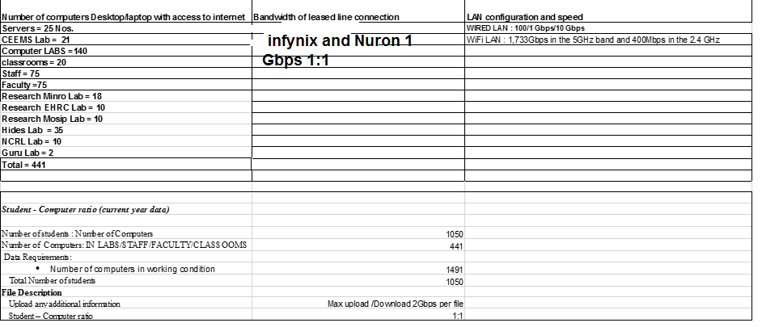

ANNEXURE II
ARUBA NETWORK Assets & LICENSES

S. No. | Product |  | Existing Licenses |  | Generated Date |  |  | L Expiry Date
1 | AMP Lic |  | 300 |  | 10-Sep-16 |  |  | Never
2 | Aruba CPPM Lic |  | 5000 |  | 14-Sep-18 |  |  | Never
2 | Aruba Mobility Master Lic |  | No |  | No |  |  | No
3 | Aruba Controller AP Capacity Lic |  | No |  | No |  |  | No
4 | Aruba Controller AP PEF Lic |  | No |  | No |  |  | No
5 | Aruba Controller AP RF Lic |  | No |  | No |  |  | No
6 | Aruba Meridian Maps 1yr Lic |  | No |  | No |  |  | No
7 | Aruba Meridian Blue Dot Nav 1yr Lic |  | No |  | No |  |  | No
8 | Aruba Meridian White Label App 1yr Lic |  | No |  | No |  |  | No
9 | Aruba Meridian Campaingns 1yr Lic |  | No |  | No |  |  | No
Building Name |  | Hub Room |  | AP 203H |  | AP 305 | AP 315 |  | AP 365 | 2930F-8G PoE+
 |  | Part No. |  | JY693A |  | JX936A | JW797A |  | JX966A | JL258A
Innovation Center |  | Left Wing
 |  | Ground Floor |  |  |  |  | 4
 |  | 1st Floor |  |  |  |  | 4
 |  | 2nd Floor |  |  |  |  | 4
 |  | 3rd Floor |  |  |  |  | 4
 |  | 4th Floor |  |  |  |  | 4
Academic Block Aryabhata |  | Ground Floor - IDF 1 |  |  |  |  | 5 |  |  | 1
 |  | Ground Floor - IDF 2 |  |  |  |  | 4 |  |  | 1
 |  | Ground Floor - IDF 3 |  |  |  |  | 6 |  |  | 1
 |  | 1st Floor - IDF 5 |  |  |  |  | 6 |  |  | 1
 |  | 1st Floor - IDF 6 |  |  |  |  | 8 |  |  | 1
 |  | 1st Floor - Server Room |  |  |  |  | 8 |  |  | 1
 |  | 2nd Floor - Room 311 |  |  |  |  | 4 |  |  | 1
 |  | 2nd Floor - Room 306 |  |  |  |  | 7 |  |  | 1
 |  | 2nd Floor - Room 303 |  |  |  |  | 5 |  |  | 1
Academic Block Ramanujam |  | Ground Floor - |  |  |  |  | 13 |  |  | 2
 |  | 1st Floor - |  |  |  |  | 10 |  |  | 5
 |  | 2nd Floor |  |  |  |  | 20 |  |  | 5
 |  | 3rd floor and 4th & 5th floorAuditorium |  |  |  |  | 45 |  |  | 5
Women's Hostel |  | WH1
 |  | Ground Floor |  |  |  | 6
 |  | 1st Floor |  |  |  | 6 |  |  |  | 6 switches
 |  | 2nd Floor |  |  |  | 6
 |  | 3rd Floor |  |  |  | 6
 |  | 4th Floor |  |  |  | 6
Boy's Hostel |  | Basement |  |  |  | 1 |  |  |  | 1
 |  | Ground Floor |  |  |  |  | 4 |  |  | 1
 |  | 1st Floor |  |  |  |  | 16 |  |  | 1
 |  | 2nd Floor |  |  |  |  | 17 |  |  | 1
 |  | 3rd Floor |  |  |  |  | 22 |  |  | 1
 |  | 4th Floor |  |  |  |  | 22 |  |  | 1
 |  | 5th Floor |  |  |  |  | 22 |  |  | 1
 |  | 6th Floor |  |  |  |  | 22 |  |  | 1
 |  | 7th Floor |  |  |  |  | 22 |  |  | 1
 |  | On-site Spare |  | 2 |  |  |  |  |  | 1
 |  | Total |  | 2 |  | 31 | 233 |  | 0 | 10
 |  | Grand Total |  | 42 |  | 71 | 380 |  | 0 | 0
 |  | Server / Hub Room

