## **Annexure 14: RFP Background and Program Overview**

**9.14.1 Background**

MahaVISTAAR project is an initiative designed to establish a OpenAgriNet (Beckn Protocol-based open network and an AI-powered layer specifically tailored for the agricultural sector) in Maharashtra. Its primary goal is to create a decentralised, interoperable, and inclusive ecosystem capable of delivering agricultural services at a large scale. The project's initial phase was conducted from March 4th, 2025, to June 30th, 2025. This initial phase focused on laying the foundational technological layers for both its Network and AI components. Building on this successful execution and the critical need to maintain momentum, the project is now initiating an open bidding process for Phase 2 development to further expand and enhance the infrastructure

**9.14.2 Overview of** OpenAgriNet **Initiative**

OpenAgriNet – is a global coalition of innovators, governments, and organisations committed to revolutionising agriculture by leveraging digital public infrastructure (DPI) and AI. Its overarching mission is to support countries in transforming agriculture for a smarter, more resilient future, particularly in developing areas, and to address challenges like climate change and limited farmer access to essential services. OAN operates as an AI-powered DPI effort that enables open and decentralised Digital Agriculture Grids, functioning as a "network of networks" with open protocols and data standards. The initiative aims to create a decentralised, interoperable, and inclusive ecosystem capable of delivering agricultural services at scale

**9.14.3 Overview of** OpenAgriNet **MahaVistaar**

**MahaVISTAAR** is the **first pilot implementation of OpenAgriNet (OAN) in Maharashtra**, designed as a **Beckn Protocol-based open network and an AI-powered layer specifically tailored for the agricultural sector** in the state. During the initial phase, five critical use cases were integrated: weather updates, mandi price information, standard operating procedures (SOPs) from agricultural universities, warehouse availability, and Custom Hiring Center (CHC) equipment listings. MahaVISTAAR is envisioned to reach **5 lakh (500,000) farmers every week starting July 2025** and aims for **20% of Maharashtra farmers to actively use the app**, with seamless **Agri-stack integration** for secure and scalable farmer data management. The platform also includes a dashboard for tracking user queries and providing analytics.

The **technical components of MAhaVistaar System** are foundational to its design:

1. **Beckn Protocol-based Open Network Infrastructure**: This forms the core, aiming to connect various stakeholders across the agriculture value chain, including farmers, agribusinesses, government bodies, financial institutions, and consumers, fostering more effective collaboration. The **network layer** is designed with a **cloud-agnostic architecture hosted on government-managed data centres**, ensuring compliance, scalability, and data sovereignty. It incorporates domain-specific standards tailored to the agricultural sector. The architecture includes Beckn Adaptor (Provider and Seeker), a Beckn Registry, and a Gateway.
2. **AI-powered Layer**: This component provides **intelligent, conversational support to farmers** through an **AI-powered chatbot**. The chatbot supports **voice and text inputs** and is functional in **Marathi and English**. It features a **modular architecture** allowing integration with various **Large Language Model (LLM) providers, including OpenAI, Google Gemini, and self-hosted LLMs**. This also includes **AI-powered cataloguing systems** for smarter data management, enabling informed decisions and efficient data discovery. Query processing involves AI translation (Bhashini), Vector Search Tools, and LLM Agents (Llama) integrating with external APIs.
3. **Toolkits**: OAN offers various toolkits including **Outcome Visualisation, Network enablement, Technical Architecture, and Digital Public Goods**.

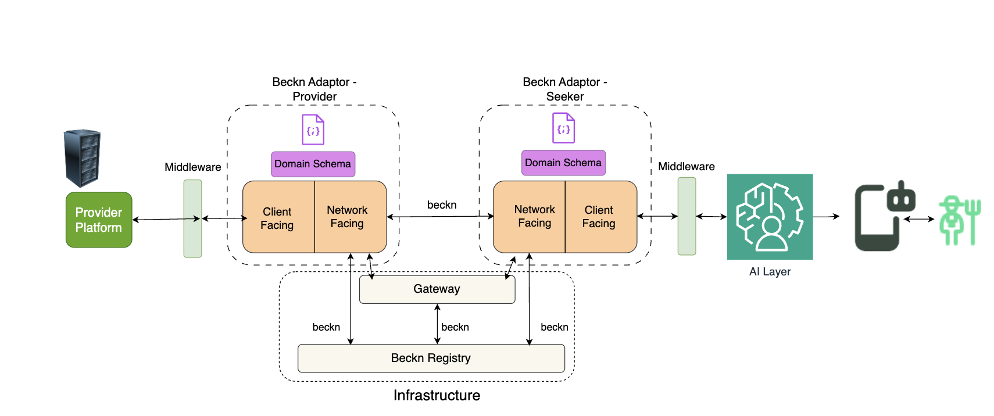

Fig 1: MahaVistaar current architecture

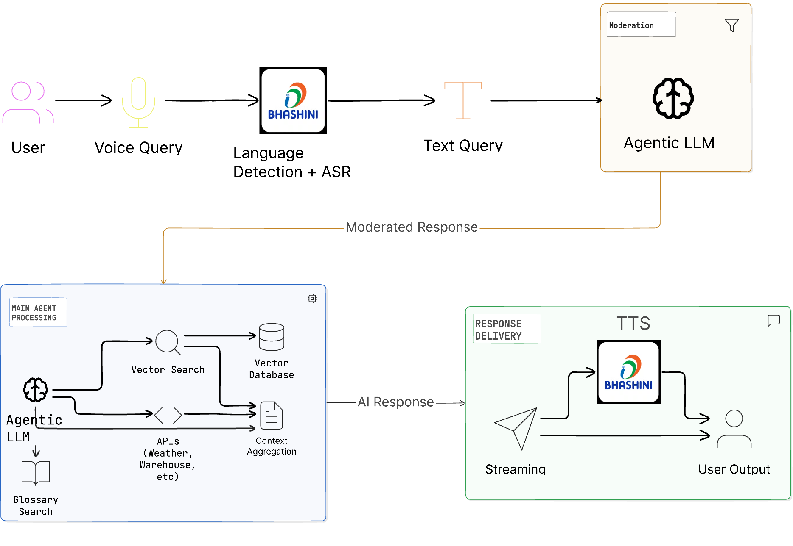

Fig 2: AI module Architecture

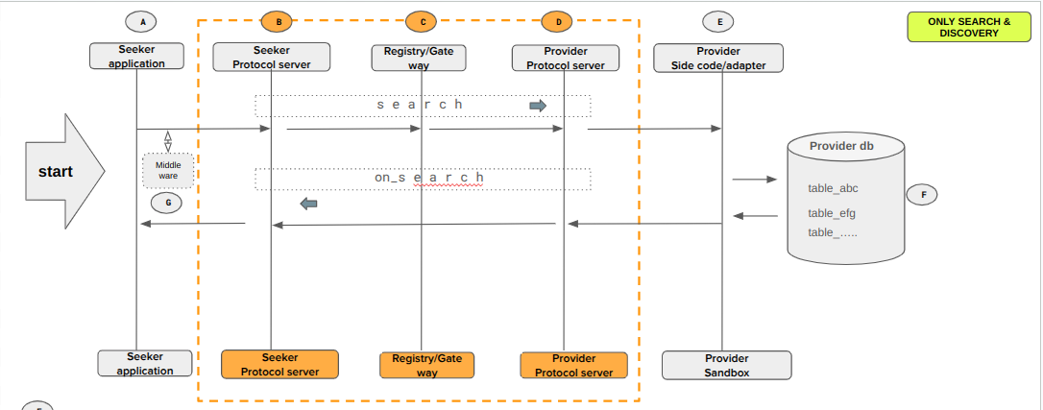

Fig 3: Architecture indicating the search and discovery over the network

**9.14.3 Reference Documentation**

1. **Github** [**project**](https://github.com/OpenAgriNet)
2. [**Gitbook**](https://app.gitbook.com/o/-Mi9QwJlsfb7xuxTBc0J/s/9VMhOCU8hRnCcIMGMb1c/)